

Distances Identification

Passbook Layout Standards

version 1.0.1

<https://sourceforge.net/projects/distancesid>

<https://twitter.com/distancesid>

Author: Dr. Simon A. Roberts  
[wishcraft@users.sourceforge.net](mailto:wishcraft@users.sourceforge.net)

Table of Contents

Foreword 3

Passbook Layout + Printing 4

Avatar Information Page 4

Document No. 5

Place of Birth / Conscrecration 5

Holders Signature 5

Issuing ISO 5

Type / Typal 5

Name / Nom 5

Nationality 5

Date of Birth / Date of Conscrecration 5

Sex / Gender 5

Date of Issue 5

Date of Expiry 5

Authencity / Authorised 5

Security Armor Key Page 6

Information Seal Page 6



# Foreword

The Distances Identification is a federated network for travel documents and identity information; it is printed as a passbook, that they can receive stamps and other identity information while travelling ports and borders of nationalities.

The idea of Distances Identification is to offer multilateral travel in a unified solution, it also includes some important medical information your active motabolism alleles for prescription as well as more security for articles and tabled information with a security key that can be OCR for access to articles as well; it also include fiscal information in your homeland nationality for billing and references.

The federated network consist in a cloud of operators that house their own information and details; these operators are nationality that is a principle system of political standard for a national basis of merit and incursion of issuing distances identification; they have been verified on the network and may exist within a planet, intrasolar, intersolar, transolar, or even intergalactic or transgalactic as well as transversal bounds within the federated network.

The federated network does provide valued trust scores as well as details of visa in loose summary to travelling hosts or finite checkin for visa qualifications and disciplines. The network also merits for fraud and counterfiet measures and prevention strategies as well as maintain a duress to travellers where nationality will be able to tell progressive notional information on the network to their citizen and border crossing they are in the process of or have done since return or leaving their nationality lands.

This federated network and it cloud of operators are looked up at a central source for network retrieval off the cloud by polling api’s for information and reciepting travel of their citizen, unlike passport, travelog, traveway and so other, the information on the network is kept by the central repository by that nationality, it is not a centralised only source but a decentralised cloud, that allows for nationality to customise the field and requirements of API (Application programmable interfaces) that may have more or lesser degree’s of data and information, there will be a minimal they are tested for too be online on the federated network – distances!

Distances Identification as a network, allows for easy retrival with a barcode at the code-128 barcode at the bottom with the centralised source retrival key for border crossings, so it is easier to handle for both the holder and the border security staff; it allows for congruency and confluencies without the problems of older systems, plus it allows for a maintenance of data that allows the traveller easy embassy access, with them embassies able to be polled by their own nationalities nodes in the cloud to notify of arrivals and departures as well as critical chronologistical information that can make response and direct calling by port an easier enterprise for all with any voyage they take.



# Passbook Layout + Printing

The passbook can be anywhere between 28 – 42 pages internally it needs to be a darker colour but you can have your nationality emblem on the outside front, with the word: DISTANCES – underneath it, with a flag for nationality or creed in nationality at the base, there is 3 internal pages that are required they are:

1. Distances Avatar Information Page
2. Distances Security Armor Key Page
3. Distances Information Seal Page

Unlike the previous systems mentioned like passport, travelog, traveway, distances has 3 tier tiled pages, so counterfiet is much harder, the key is similar to an SSL CSR Key, and can be defined by the nationality or generated off the core nodes, it really up to you it just has to be capable of easily having a photo on a phone or scanned for OCR of the key for extra access to articles so on the federated network.

You will find the graphic templates for these three internal pages here: [https://sourceforge.net/p/distancesid/historical/HEAD/tree/Media/Document%20Standards/](https://sourceforge.net/p/distancesid/historical/HEAD/tree/Media/Document Standards/).

## Avatar Information Page

Below is the avatar information page, this appears on the inside 2nd page with either front or back facing this page in the passbook.

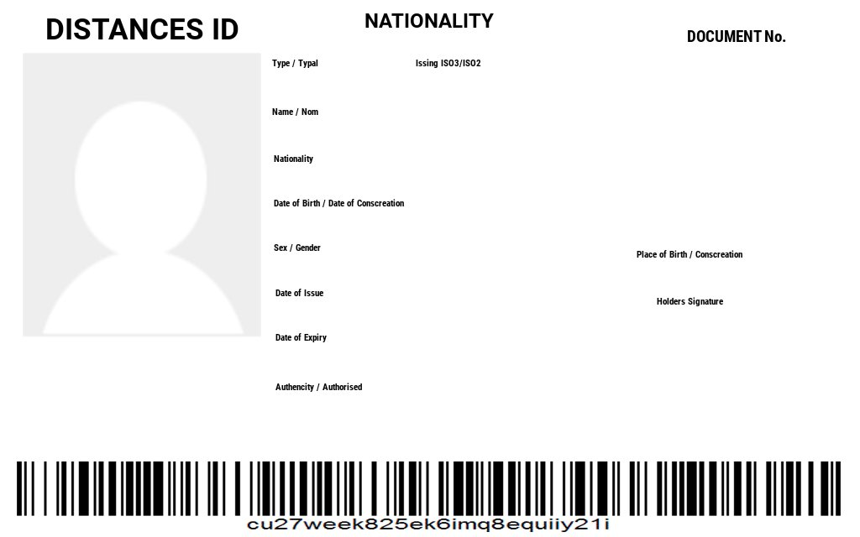

You can see it is similar to passport, but the easy handling code-128 barcode at the bottom allows the travellers checkin nationality to poll the nationality node which references the document no. + barcode while in border security for visa and other entitlements.

The following fields are for the mentioned information

### Document No.

Passbook document numbers there is a prefix list here on feed for general purposes: [https://distancesid.sourceforge.net/api/passbook/prefix/index.php?format=json](https://distancesid.sourceforge.net/api/passbook/types/index.php?format=json).

### Place of Birth / Conscrecration

Place you have been born or conscrecrted spawning through marriage or cloning.

### Holders Signature

A visual copy of your signature

### Issuing ISO

This is the nationality issuing iso in 2 – 8 characters.

### Type / Typal

This is the type of passbook it is these are single or dual character symbols taken from <https://distancesid.sourceforge.net/api/passbook/types/index.php?format=json>.

### Name / Nom

This is the person or holders name.

### Nationality

This is the person or holders nationality.

### Date of Birth / Date of Conscrecration

This is the person dob or doc if they are clone or spawned.

### Sex / Gender

This is the type of passbook it is these are single or dual character symbols taken from feed <https://distancesid.sourceforge.net/api/passbook/genders/index.php?format=json>

### Date of Issue

Date the passbook was issued.

### Date of Expiry

Date the passbook expires – can be set to: never.

### Authencity / Authorised

The authencity serial number for the nationality that has issued the passbook; there is a queriable api at: <https://distancesid.sourceforge.net/api/passbook/authencities/index.php?format=json>

## Security Armor Key Page

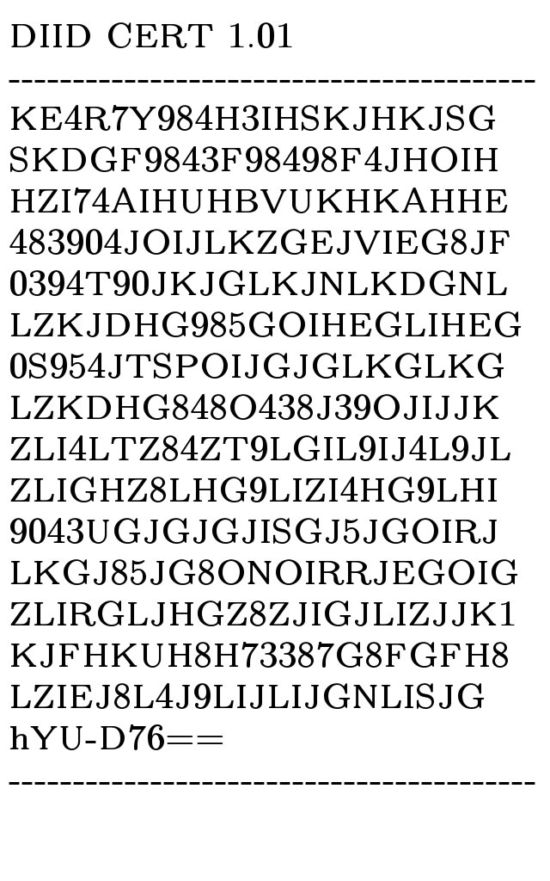The security armor key is used for OCR, so this and the information seal page is printed in and on stark white, or starch white background.

The certificate must have it title and version, then the key part is surrounded in the full length by a dash (-) repeated, as seen in the example on the left. The key is finished with their 3x3 character signing prompted signature key followed by equal equal (==).

This armor key is required to access the articles apart from title, date, summary, and checking public stamps for the articles. Based on your own is the realative level of access you have to either for read, write, submit and so on nationalities nodes, the articles are in HTML5 which can have file attachments, if the file attachments are shared publically then they will be available in the summary access without having to photo and OCR the key.

Any fonts your printing this key in need to be uploaded to: <https://distancesid.sourceforge.io/uploads/fonts>

## Information Seal Page

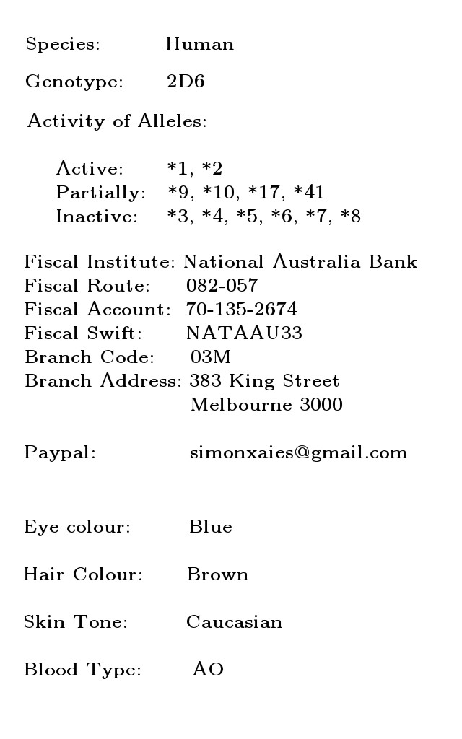The vital medical information such as: Species, Genotype + Actibity of Motabolism Alleles are captured as part of the application where they are in part of a “Distances ID Ordering Kit” are given a buckle swab (This is one of the sampling wands with a bristle circle on the outside at one end against the wands shaft).

This swab wand which is rubbed on the inside of the cheek and individual serialised with a sticker and sent in the post too your processing area, if the sample is bad they get mailed for another one until you have the Alleles that are active in the passbooks holder body, this is vital for prescription of any medicine.

You need to include the holder of the passbook bank details, as well if they have it a paypal or similar if you like, this part is really up to you can as nationality include any further identify questions or answers in this section the fields for here will be open for your selection.